DIGITAL X-RAY REPORT
NAME: ARSHI AGE: 39Y/F
UHID : 93529 DATE: 21-06-2019
INTRAVENOUS UROGRAPHY :
Plain X-ray K.U.B. area: Radio-opaque opacity seen overlying the transverse process of L2 vertebra on right side and between the transverse process of L2-L3 vertebra on left side.
Both Psoas shadows normal.
Bones under view unremarkable.
IVP examination: Done with IV injection 50 ml of Contrapaque and films taken at different intervals . Prone
films were also taken.
Right kidney : shows normal nephrogram and concentration of contrast media .
Grade 2 hydronephrosis with hydroureter seen upto the calculus .
Left kidney : shows normal nephrogram and concentration of contrast media .
Grade 1 hydronephrosis with hydroureter seen upto the calculus .
Urinary Bladder: Normal in shape, regular in outline.
Please correlate clinically.

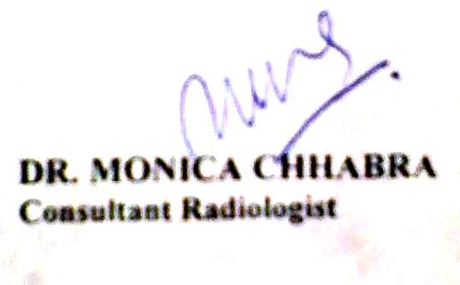

DIGITAL X-RAY REPORT
NAME : SANTOSH RAO AGE/SEX : 41Y/F
DATE : 21/06/2019 UHID : 93057
X-RAY CHEST PA VIEW:
Both the lung fields show no active parenchymal pathology.
Both the costophrenic angles are clear.
Heart size is normal.
Both the domes of diaphragm are normal.
Bony thorax appears normal.
Suggested : Clinical correlation

